ISE361: Introduction to Database Systems
Semester 081
LAB SECTION- 51
Lab # 1: Introduction to Lab & DB Architecture

Objective:
1-Oracle Software and CD
2-Introduction to Oracle, its Architecture & Versions
3-Database lab orientation
4-Sample Database Applications
Scope:
The student should know the following:
- Oracle Installations issues
- Introduction to Oracle and its applications
- Oracle Versions etc.

Useful Concepts :

1-Oracle Software version 10g and CD:
\\ccse-software\applications\DatabaseApps\Oracle\oracle10g\10g_win32_db.zip

2-Client Server Concepts
Installation details are given on my web page

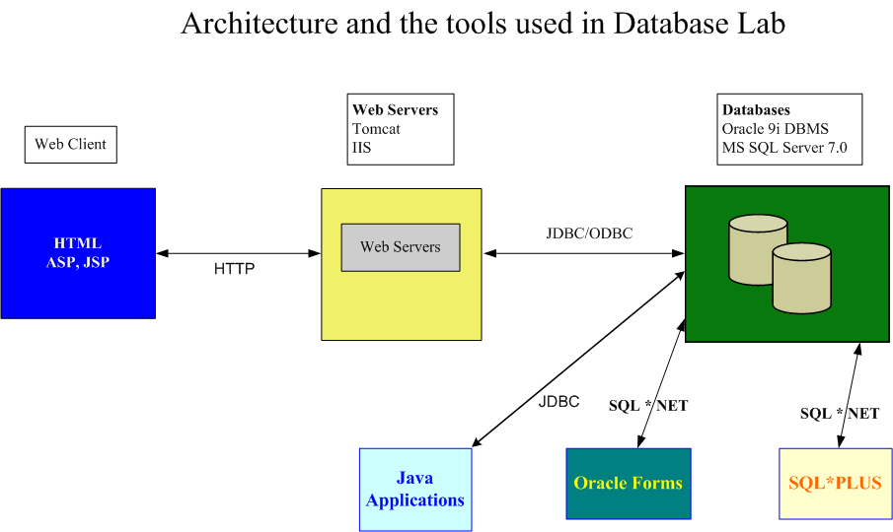

Discussion:
None

Authorization Issues
Make sure that you have the following accounts with proper permissions.
- Windows account to access the lab machines with enough disk space. Whom to contact in times of need
- Oracle database account. (the instructor will be giving you these accounts)
- Web server access.
- Webcourses account at http://webcourses.kfupm.edu.sa
Useful Resources
- http://webcourses.kfupm.edu.sa
- For software and reference manuals
  - \\ccse-software
  - http://soft.kfupm.edu.sa
- www.oracle.com
- http://technet.oracle.com
- http://asktom.oracle.com
- http://oai.ccse.kfupm.edu.sa

Exercises:
None

Evaluation:
Your Lab Work grade will depend on your active participation, individual efforts in solving Lab Problem and Seriousness during the lab.

