ICS 202 | Quiz Number 3
ID: | Name:
Closed Book Quiz. You have exactly 20 minutes.

- Write the assignment statement(s) required to transform Figure 1 to Figure 2:

Figure 1:  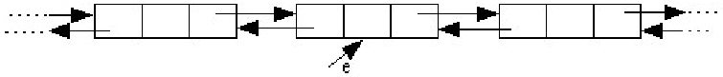 | Assignment statement(s):
Figure 2:  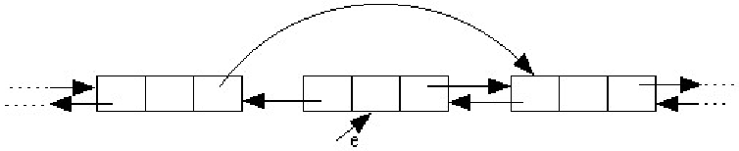 | Assignment statement(s):

- list1 is a DoublyLinkedList object initialized with Integer objects having the following values: list1 = {1,2,3,4,5,6}

What is the output of the following code fragment?
list1.myMethod(new Integer(3));  System.out.println(list1);  list1.myMethod(new Integer(5));  System.out.println(list1); | Output:

The method, myMethod, is defined in DoublyLinkedList class as follows:

public void myMethod(Object obj) {
Element e = head;
while(e!= null) {
if(e.data.equals(obj)){
e = e.next;
if(e!= null && e.next != null){
e.next.previous = e.previous;
e.previous.next = e.next;
}
return;
}
e = e.next;
}
head = head.next;
}
- Write a method, public static void duplicate(Stack stack), that will cause every element in the parameter stack to be duplicated. For example, if the stack contains integer objects [1, 2, 3, 4], after calling the method, it must contain [1, 1, 2, 2, 3, 3, 4, 4].

