Monday, November 12th, 2007 @ 15:30 – 16:50, Dana 2 Hall
Industrial Technology I: Applications Supporting Oil & Gas Industry
The complexity and criticality of managing oil and gas business applications using information Technology systems can become complex as the process itself if not managed properly. In the oil and gas industry, timely and accurate decisions are required to manage the facilities effectively. Many applications are currently available that provide the manufacturers the capabilities they need to optimize operational performance, make real time decisions and integrate their day to day activities with the supply chain. Today’s Oil & Gas industry presents a diverse set of communications needs with some unique challenges, Satellite technology can be employed with great effect to address these needs and to enhance the safety and efficiency of operations within the industry. This technical session will also introduce various wireless data technologies, architecture, and available solutions and applications applicable to industry area considering the current challenges and criticality of managing related business applications
Speaker | Presentation Title
Mr. Issam Karkoutli, Managing Director of Middle East, INOVx Solutions, USA  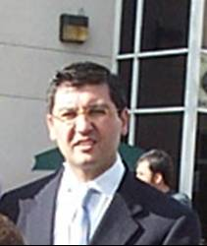  Mr. Karkoutli is an accomplished software executive bringing more than 17 years of diverse experience in the area of plant engineering / construction and advanced software applications for enterprise and asset management. At INOVx he held several lead positions in the area of product development, marketing and operations. Currently, Mr. Karkoutli holds the position of Managing Director for Middle East Region. Prior to INOVx, Mr. Karkoutli was a project manager at Fluor Corporation, leading strategic and global EPC software initiatives. Mr. Karkoutli holds a B.S. in Architectural and Environmental Design and a Master of Science in Computer Aided Design applications from Arizona State University. | Virtualization – “Bringing Reality to your Asset Management”  In an asset-intensive operation, quick and integrated access to current and accurate asset information including field physical conditions will significantly improve the decision making cycle of a wide range of daily Operation and Maintence activities. It will also enable better informed decisions with faster response time leading to achieving higher level of productivity, safety and plant reliability.  INOVx will be presenting its innovative Virtualization solution – a software platform based on the integration of 3D electronic models representing the actual physical conditions of the assets with the plant enterprise data systems such as SAP PM, OSIsoft PI, Meridium and other operation and document management systems.  Based on this user-friendly virtualization environment, plant operators are able to review, query and visualize reliability, operation and maintenance data while walking through their “virtual” physical assets right from their desktops.  Virtualization Solutions address key areas in plant asset management:  - Challenges with asset “as-built” data from capturing it, accessing & integrating it with enterprise systems to managing and sustaining it with a complete change management process.  - Strategic approach to asset management – filling the information gap in asset data management  - Enabling streamlined day to day activities for all plant functions from Operation, Maintenance to Engineering and Inspection.  - Collaboration across functional work groups at the plant enabling faster and better decisions with regards to turn around planning, system shutdown and start up sequencing, access points, isolation and safety procedures and emergency response.  - Knowledge Capture and Sharing across plant functional groups.  - Simple and easy platform with “one touch” access to all asset data based on tag numbers.
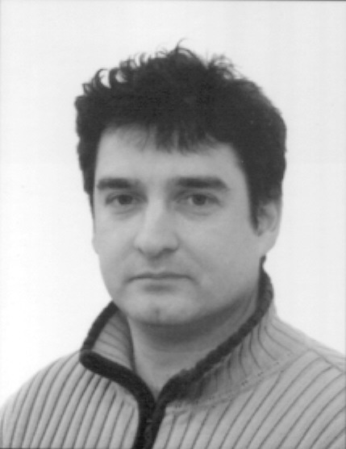  Jouni Olavi Paavonen, Chief Designer, FF-Automation, Finland  Jouni is a computer science engineer. He has over 18 years of experience on Factory automation and remote control solutions | Remote control & Monitoring  The presentation will cover the following areas:  - Communication methods; Fiber optics, Ethernet, WLAN, RF-technology, GSM/GPRS and TETRA  - Wireless sensors  - Remote maintenance; Diagnostics and Programming  - User end solutions; Scada SW, Internet/intranet, based solutions and Trouble ticket systems
Mohammed Al-Jaroudi, IT Specialist, Saudi Aramco, Saudi Arabia  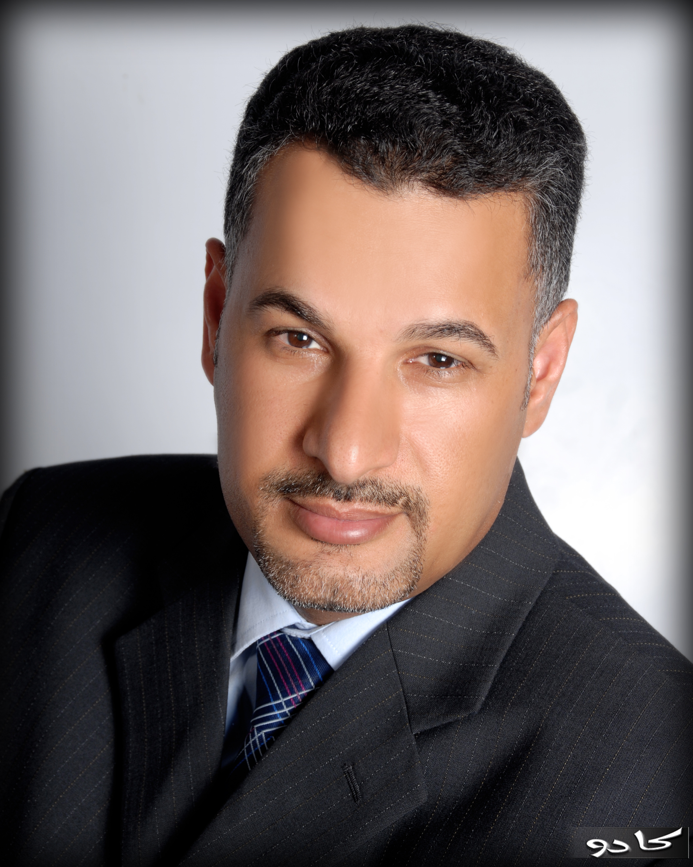  Mohammed Al-Jaroudi is a communications engineer and a satellite specialist working with Saudi Aramco Company. He holds a B. S in electrical engineering from King Fahad University at Saudi Arabia. Since 1993, Mohammed has been working in many satellite projects at Saudi Aramco Company to serve the drilling rigs, Seismic operations, marine vessels and barrages, Bulk Plant, Air Fueling and other remote operation. Mohammed led the effort to introduce all the types of Inmarsat system to serve Aramco remote operations and then introduced the VSAT system at the early of 1990s as a replacement to the Inmarsat network. He designed and led most of the VSAT/satellite projects being constructed at his company and currently, Mohammed has installed and commissioned a major VSAT DVB-RCS system in which he participated in the development of the Functional Specification Document (FSD) and the network’s design to replace the obsolete proprietary VSAT systems.  Mohammed has worked for one year with the Worldcom company, USA during the period of 2001 - 2002 as a satellite engineer and he presented several presentations and papers on the satellite communications systems at national and international events. | Broadband VSAT Services - New Perspective for Oil and Gas Applications  Oil and Gas field explorations and productions facilities operate in hard environments, very hot deserts, cold fields and open sea and ocean. They are located at hundreds of miles from their centralized offices in unpopulated areas and basic requirements such as reliable terrestrial commutations can not be granted. Harsh condition and remote locations make a reliable communications system more essential to monitor the drilling and seismic real time data, perform daily production and marketing of the bulk plants and Air Fueling and to conduct the daily maintenance of the marine offshore platforms and to respond to emergencies. Broadband VSAT (Very Small Aperture Terminal) communications is therefore a vital and a key element to support the Oil and Gas daily operations and provides means of communications with their centralized operation centers. VSAT communication networks have proven the reliability to support the oil and gas operations by providing broadband data, voice and video applications. VSAT systems have enabled the drilling and seismic operations to introduce new applications like geosteering real time applications that couldn't be achieved in the past using terrestrial communications. This presentation highlights and discusses the high potential market of Oil and Gas users and it presents also the VSAT requirements of Oil and Gas operations based on field experiences to be considered by the SatLabs Group and VSAT DVB-RCS manufacturers in order to continuously support the oil and gas industry and to provide a single VSAT DVB-RCS technology platform solution for all needs.

