Dynamic Generation of HTML Documents

Nasir Al-Darwish
ICS Dept., King Fahd University of Petroleum & Minerals, Dhahran, Saudi Arabia

ABSTRACT. We present an effective scheme for dynamic generation of HTML documents. The scheme relies on CGI and can be implemented easily. The scheme addresses the issues of maintaining the state of the client and the security of a WEB session. The utility of the proposed scheme is demonstrated in the development of a Student Pre-Registration site for KFUPM.

Introduction
Feedback forms, e-mail forms, database query and updates, text search and others are all examples of CGI applications. Several product solutions exist for the generation of HTML documents filled on the fly with information retrieved from a database. These rely on one of three schemes: template HTML files processed by a CGI program, Server-Side-Includes (SSI's), or some Server API [1,2,3]. The first scheme is popular with many products such as Cold Fusion (http://www.allaire.com) or Microsoft's Internet Database Connector (IDC) used in conjunction with Microsoft's Internet Information Server. Using this scheme a template file is used which is basically a normal HTML file that contains extra statements (meta-statements) that controls the retrieval and update of the database information. In our work this approach is followed. By implementing this scheme directly, (which is quite plausible for a sophisticated Web-designer), several advantages can be gained. The commercially available solutions force the use of ODBC to access the database. By all accounts ODBC is cumbersome and adds a layer of overhead processing that impacts the overall system speed. Also several of these solutions rely on Win-CGI that uses input and output files to pass information between the HTTP server program and the CGI program which further impacts the performance. Given that the development effort is reasonable one can write his own HTML generator providing a native access to his database of choice and having the utmost control over the generation process. In the system we developed we used Delphi to build a tiny generic Window application that accesses a Microsoft’s Access database by tapping into dao3230.dll (the DLL that implement the Access Database Engine) through OLE automation [5].

Integration of HTML and Database
The most apparent example of the need to generate HTML pages dynamically is during the interaction with a database. Consider the case of a pre-registration system. After the student’s advisor logins into the system and is authenticated, he is presented with a form to specify the student ID without requiring the advisor to supply his own ID and password again. But this presents a problem due to the stateless nature of HTTP requests. In other words, the HTTP server does not maintain any information about past requests. In the scheme being proposed the form presented in the latter request includes a hidden text entry for storing the Advisor ID in an encrypted way. Thus when this information is relayed back when the user submits the form, it can be decrypted at the server and used to verify that indeed this ID is that of the student’s advisor. Note here that while we are to maintain the state at the client (browser), this information has to be hidden so that it can not to be accessed later from the browser’s cache and replayed by an unauthorized user. Therefore, it would not suffice to use an encryption protocol like the Secure Socket Layer protocol since this encrypts the data only while it is in transit between the server and the client.

How to Encrypt?
The encryption function should detect any tampering with the hidden entry and in the unlikely case that tampering slipped detection then the decrypted information may not be useful in any further interaction (for example, an invalid Advisor ID will not fetch any student records). In our implementation we chose to concatenate the clear text with the system time and the IP number of the client and then apply a sequence of character transformations and permutations. By including the system time we get two benefits:
- Introduce an element of randomness in the encryption process that is hard to be guessed by the attacker and makes the history of past interactions less useful.
- The program handling the user’s request can compare the time retrieved during decryption to the current system time and refuses to honor requests that come late (e.g. > 10 minutes). This will prevent replaying and submission of previously saved pages. In our scheme this time difference is stored in a global variable Timediff which is set every time the decryption function is called - see Fig. 1.
To facilitate the above requirements we have built a CGI program (genhtm.exe) that process a template file (with file extension of .htx) whose name is supplied as the first command line argument and optionally followed by additional data which would be passed in the CGI’s QUERY_STRING environment variable. The template file is basically a normal HTML document that contains some meta-statements to be processed and acted upon by the generator to build the final HTML document. These statements specify SQL queries such as select and insert SQL statements. The other primary statements are the assignment and if statements. These help to pass the state from one HTML page to the next and control the content of the generated page.

Meta-Statements
The general syntax of a meta-statement is either
<<statement-type ... >>
or
<<statement-type ... >> ... <</statement-type>>
Here is a list of the basic meta-statements.
- <<db databasename [dbtype]>>
- <<in[:method] var1 var2 ... >>
- <<= var=expression>>
- <<sql query>>body <</sql>>
- <<if cond>>body<</if>>
- << ... %var1 %var2 ... >>
- <<begin Title>>
- <<end>>

Here is a description of each of the above statements.
The first statement specifies the database name (including full path). In the current implementation we assumed that this is a Microsoft Access database. By having the db-type argument it is possible to support other databases such as FoxPro.
The second statement specifies the variables (and values) passed at the time the script is invoked by the generator. The optional method parameter specifies the corresponding CGI method used (GET or POST). This defaults to GET where variable/value pairs are passed as part of the command line and retrieved by the generator from the QUERY_STRING environment variable. The generator will verify the presence of these variables in the QUERY_STRING and initialize them to their corresponding passed values.
The third statement is the assignment statement which has the form variable=expression. This can override the value of an existing environment variable or introduce a new environment variable. The expression can be a function call to one of the encryption, decryption functions Enc and Dec respectively.
The fourth statement is the SQL statement. In the case of a select statement, the generator will repeat emitting the body as many times as there are records produced by the select statement. Before evaluating the query any %var in the query part will be replaced by its value. Note that query part introduces new environment variables - namely those that appear in the field list of the select clause. Thus any reference to %var in the body part of the SQL statement will be replaced by the value of the corresponding variable. It is possible that the body be empty and then the SQL statement serves to introduce extra variables and values into the environment which can be accessed outside of the SQL statement. For example, in Fig. 1 the first SQL statement sets the value of StID and StName and StID, which are referenced later.
The fifth statement is the If statement which is limited in the current implementation to a then part only. The sixth statement is used to output the values of the environment variables.
The <<Begin Title>> statement forces the generator to restart building the document and it is a shortcut for <html><head><Title>Title</Title></head>. Like wise the <<end>> statement forces the generator to stop scanning any further and is a shortcut for </body></html>. As an illustration of the use of the preceding statements consider the text shown in Fig. 1. This is a listing of the file getplan.htx which is invoked upon clicking on Get Plan button (see Fig. 2) using the request (as a form action parameter) action="/genhtm.exe/getplan.htx". According to this template, the system would verify that indeed this student is advised by this advisor (the first SQL statement) and present the appropriate page; either a page with an abort message or a pre-registration form as shown in the right pane of Fig. 3.
<<begin Plan>>
<<in StID EncAdvID>>
<<AdvID=Dec(EncAdvID)>>
<<if TimeDiff >10>> Connection is broken due to timeout <<end>>
<</if>>
<<db reg.mdb>>
<<sql select StID, StName, AdvID from tStAdvisor where (AdvID=%AdvID) and (StID=%StID)>>
<</sql>>
<<if StID="">> No student record; possibly invalid Student ID <<end>>
<</if>>
<<<B>Student ID: </B>%StID <B>Name: </B>%StName>><hr>
<<sql select CourseID, CourseName, CourseHrs from qCoursePlan where StID=%StID>>
%CourseID %CourseName %CourseHrs
<</sql>> <<end>>

Fig. 1. The content of the file getplan.htx

Fig. 2 shows the main screen in the proposed pre-registration system. It consists of three panes (built using the HTML frameset and frame tags). The command buttons in the top pane control the contents shown in the two lower panes. The left pane lists the department names. Upon clicking on a department name, the pane content is overwritten by listing the courses offered by that department - See Fig. 3. Clicking on the Dep. List button causes the pane to list department names again. The right pane shows announcements whenever the Announcements button is clicked or a student plan if the Get Plan button is clicked - See Fig. 3.

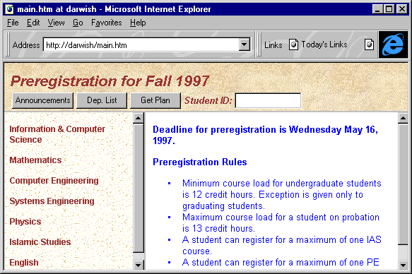

Fig. 2. The main screen of a proposed KFUPM pre-registration site showing department names (left pane) and announcements (right pane).

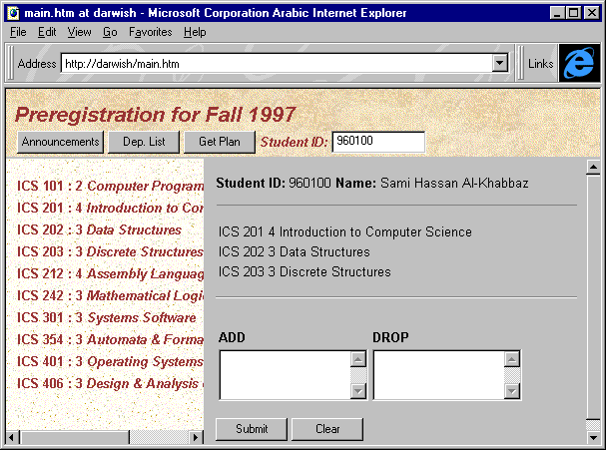

Fig. 3. The main screen showing courses offered by a particular department (left pane) and a pre-registration form for a particular student (right pane).

Conclusions
In this paper we have discussed the implementation of a scheme to generate HTML documents dynamically. The scheme resembles some of the solutions that are available commercially. As a part of the proposed scheme, we presented a solution to the problem of maintaining and securing the state of the session.

ACKNOWLEDGEMENTS
The author would like to acknowledge the support given by King Fahd University of Petroleum and Minerals toward developing several WEB applications.

References
[1] Hettihewa, Sanjaya, Windows NT 4 Web Development, Sams Net,1996.
[2] Surfas, Mark and Chandler, David, Running a Perfect WEB Site with Windows,
Que Corporation, 1996.
[3] Jones, Kriten L., nif-T-nav: “A Hierarchical Navigator for WWW Pages.”
Computer Networks and ISDN Systems. Vol. 28, May 1996.
[4] Pacheco, Xavier and Teixeira, Steve, Delphi 2 Developer's Guide, SAMS Publishing, 1996.
[5] Weinmann, William, The CGI Book, New Riders Publishing, 1996.

