**Jupyter Installation and Setup**

# Anaconda installation

Anaconda is a popular platform of the Python and R programming languages for scientific computing (data science, machine learning applications, large-scale data processing, predictive analytics, etc.). to install it, proceed as follows.

## Go to the Anaconda Website at <https://www.anaconda.com/products/individual> and scroll down to the Anaconda Installers section as shown below

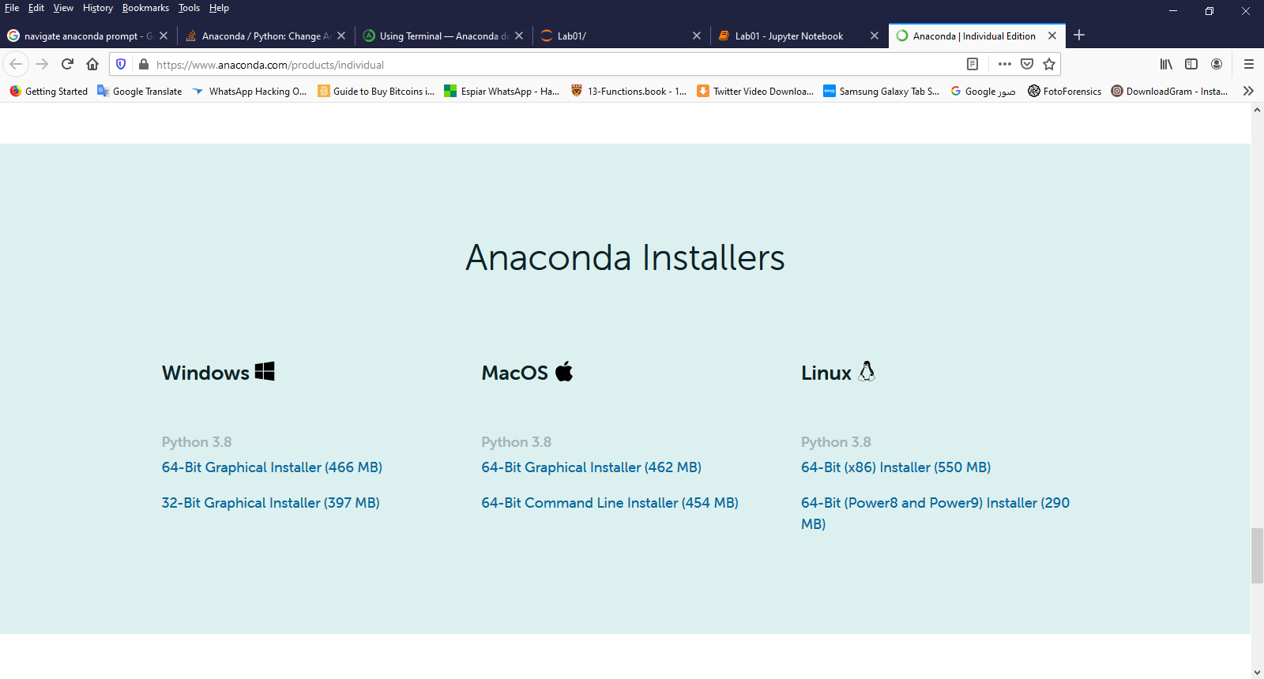

## For Windows, download the Graphical installer that match your system type

You can get your system information by right-click the Computer icon on the Desktop and then select “properties”

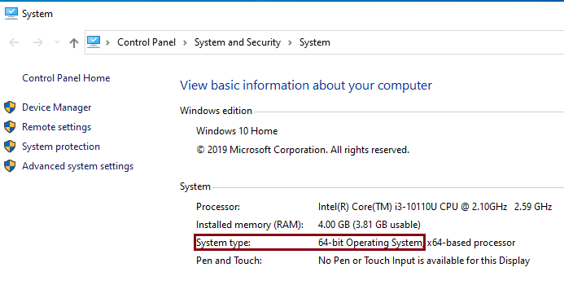

For 64-bit Operating System, download the [64-Bit Graphical Installer (466 MB)](https://repo.anaconda.com/archive/Anaconda3-2020.07-Windows-x86_64.exe).

For 32-bit Operating System, download the [32-Bit Graphical Installer (397 MB)](https://repo.anaconda.com/archive/Anaconda3-2020.07-Windows-x86.exe).

For Mac users: Choose the [64-Bit Graphical Installer (462 MB)](https://repo.anaconda.com/archive/Anaconda3-2020.07-MacOSX-x86_64.pkg)

## Go to your download folder and then open and run the .exe installer, “Anaconda3-2020.07-Windows-x86_64.exe”, you will get Anaconda installer and just click “Next”, “I Agree”, “Install” or “Finished” buttons on all windows. Wait for installation process to finish.

## After the installation process is finished, in the start menu search bar, type “Anaconda”, you will find that many Anaconda related tools are installed (Windows). As shown below.

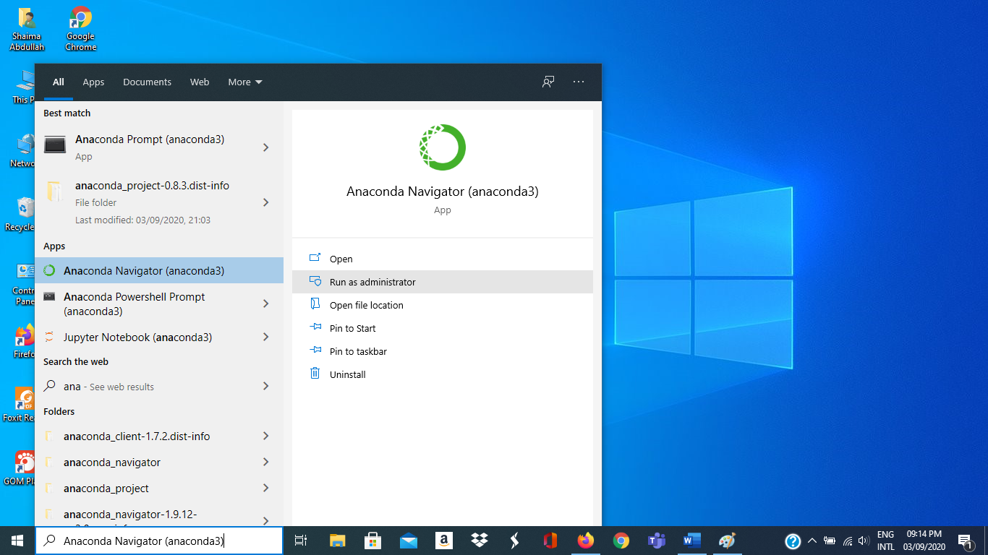

## Launch the **Anaconda Navigator** tool. It is a desktop GUI that comes with Anaconda. It makes it easy to launch applications and manage packages and environments without using command-line commands.

## Launch “Jupyter Notebook” and start writing Python programs.

|  |  |
| --- | --- |
|  |  |

# Installing RISE

RISE is an extension that allows you to display lecture and lab notebook cells as a presentation on the web browser. To install it, follow the following instructions

## Start a command prompt as follows:

|  |  |
| --- | --- |
| On Windows, run  *Anaconda Prompt (Anaconda 3)* as administrator | On Mac, run  *Terminal* |

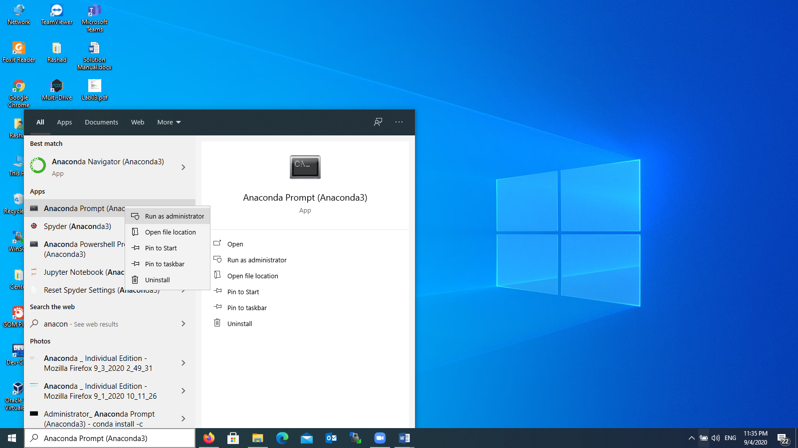

## Type the following command

**conda install -c conda-forge rise**

After successfully executing this command, you will get messages as shown below

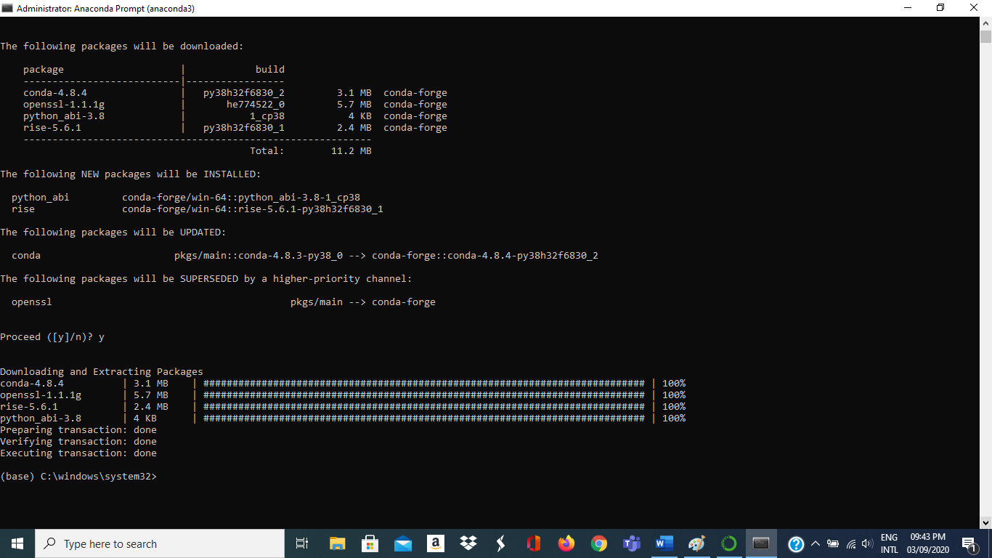

## Shut down the current Jupyter session and restart it, so that the RISE button will appear on an open Jupyter notebook.

# Installing nbextensions

nbextensions is a graphical user interface that allows you to add and customize many extensions available to Jupyter. To install it,

## Start a command prompt as follows:

|  |  |
| --- | --- |
| On Windows, run  *Anaconda Prompt (Anaconda 3)*  As administrator | On Mac, run  *Terminal* |

## Type the following command:

**conda install -c conda-forge jupyter_contrib_nbextensions**

After successfully executing this command, you will get messages as shown below

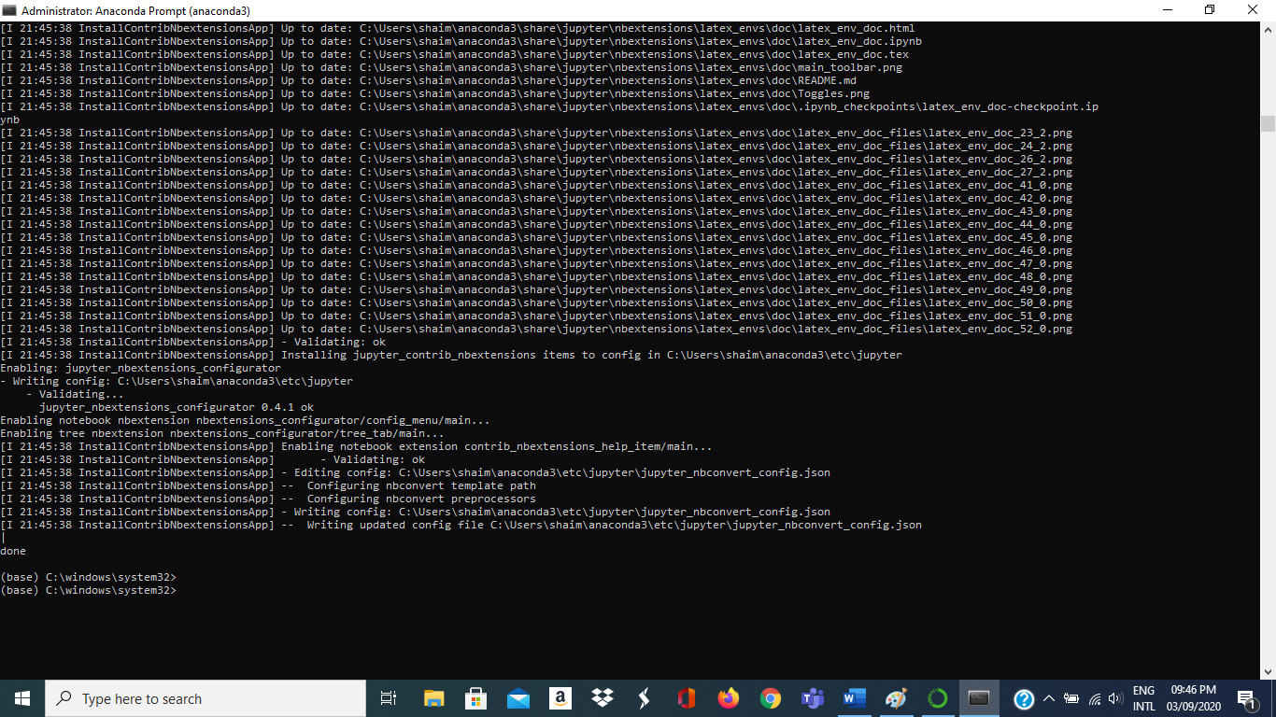

## Shut down the current jupyter session and restart it, so that the nbextensions button will appear.

# Nbextensions settings:

In order to set jupyter notebook to use various features, follow the following instructions:

## Launch Jupyter notebook from the Anaconda Navigator, or through starting a command prompt (as before) and type the following command:

jupyter notebook

## A tab *nbextensions* will appear. Click it.

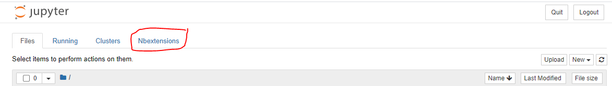

## Check mark the following nbextensions (as shown in the following figure):

|  |  |
| --- | --- |
| Option | Short Description |
| *Hinterland* | Enable code autocompletion menu for every keypress in a code cell |
| *Move selected cells* | Move selected cell(s) using keyboard shortcuts Alt-up and Alt-down |
| *ScrollDown* | Scroll outputs down automatically |
| *spellchecker* | Spell checker for the markdown cells |
| *Split Cells Notebook* | Enable split cells in Jupyter notebooks |
| *TableOfContents (2)* | Enables to collect all running headers and display them in a floating window, as a sidebar or with a navigation menu. |

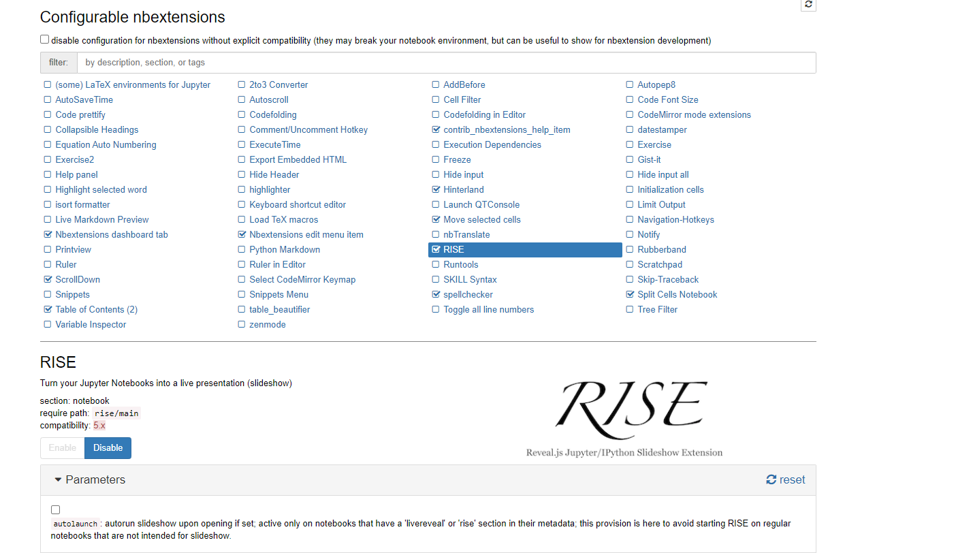

**Note**: If you do not see the list of extensions as show above, then perform the following steps:

## Start a command prompt as follows:

|  |  |
| --- | --- |
| On Windows, run  *Anaconda Prompt (Anaconda 3)*  As administrator | On Mac, run  *Terminal* |

## Type the following command:

**jupyter contrib nbextension install -–user**

## Shut down the current jupyter session and restart it, so that the list of extensions will appear.

# RISE settings:

Select the RISE extension (click on it once) in nbextensions, then go down and make sure that scroll is check-marked, as shown in the following figure.

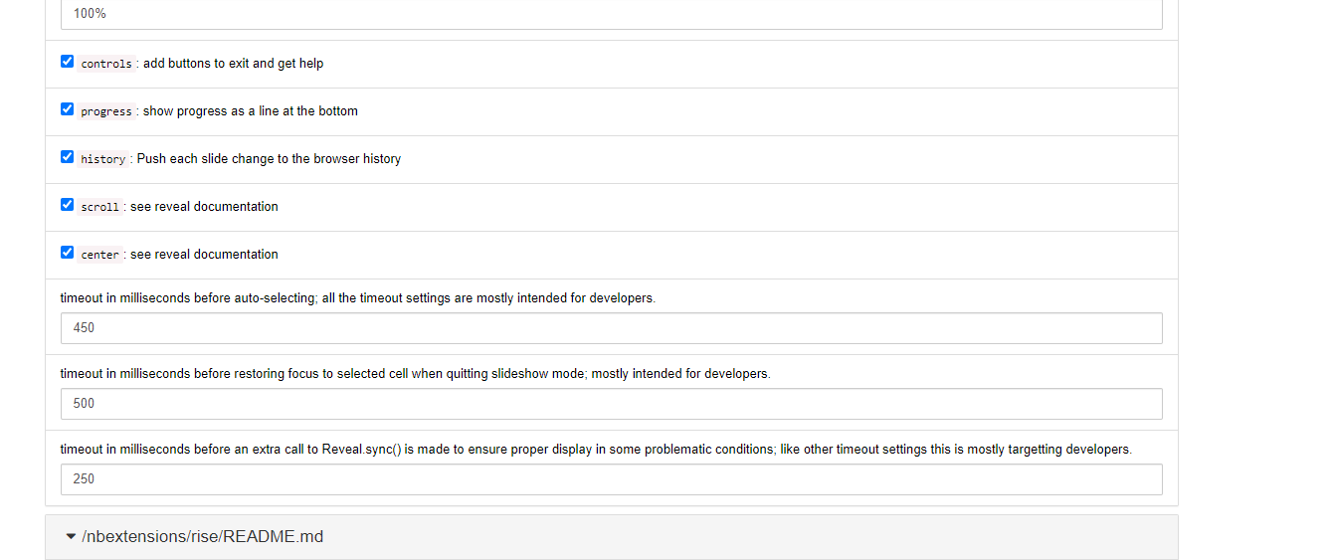

# Changing the Default Directory for Jupyter

When you start Jupyter notebook, it will go to the default directory of your account (e.g. “C:\Users\username”. In order to make it start from your ICS 104 directory where you keep your Jupyter notebooks, do the following:

|  |  |
| --- | --- |
| On Windows, run *Anaconda Prompt (Anaconda 3)* as administrator | On Mac, run  *Terminal* |

## Then type the following command **jupyter notebook --generate-config**

This writes a file to C:\Users\username\.jupyter\jupyter_notebook_config.py.

(On Mac, the file is /Users/username/.jupyter/jupyter_notebook_config.py)

## Browse to the file location and open it in text editor such as notepad++

*Note: You have to enable your explorer to see hidden files to be able to see the .jupyter folder*

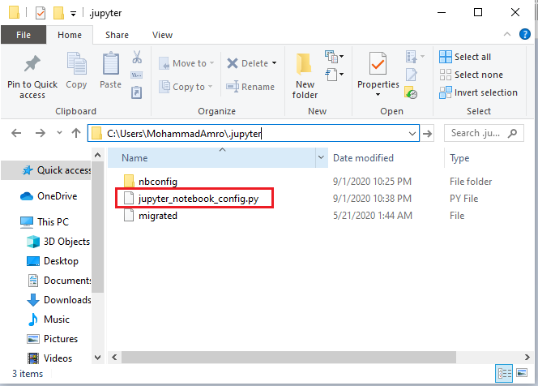

## Search for the following line in the file:

***# c.NotebookApp.notebook_dir = ''***

## Uncomment the line (removing the # sign) and replace it by the path of your ICS104 directory. For example,

*c.NotebookApp.notebook_dir = 'C:/Users/MohammadAmro/Dropbox/ics work/201-ics-104'*

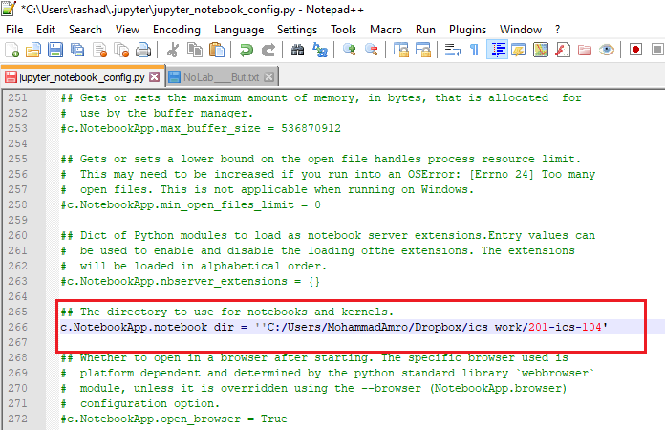

## Make sure to you use forward slashes in your path and to save the file.

# Short-Cuts and Their Customization

In order to check shortcuts and customize them, open any jupyter notebook, such as the one shown below, Click on Help and then Keyboard Shortcuts for a list of available shortcuts and for editing/adding any shortcuts, if needed.

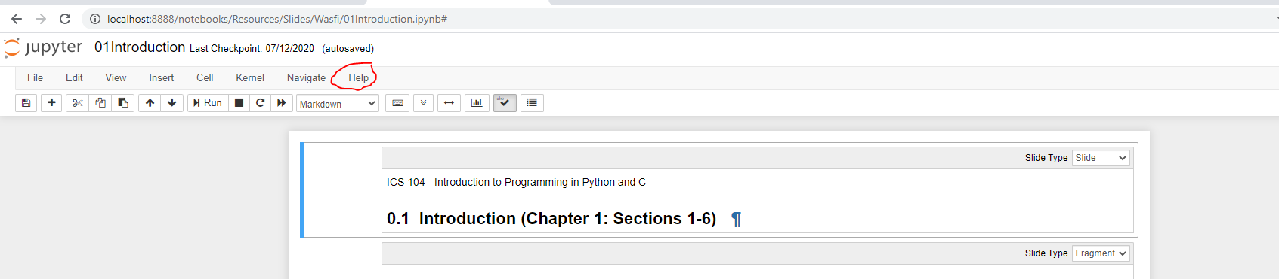

# Links for Learning more on how to use, install and create Jupyter Notebooks

1. [Jupyter Notebook: An Introduction](https://realpython.com/jupyter-notebook-introduction/).
2. [Jupyter Notebook Tutorial: Installation, Components and Magic Commands](https://blog.quantinsti.com/jupyter-notebook-tutorial-installation-components-magic-commands/).
3. [Learn How to Write Markdown & LaTeX in The Jupyter Notebook](https://towardsdatascience.com/write-markdown-latex-in-the-jupyter-notebook-10985edb91fd).
4. [Optimizing Jupyter Notebook: Tips, Tricks, and nbextensions.](https://towardsdatascience.com/optimizing-jupyter-notebook-tips-tricks-and-nbextensions-26d75d502663)